"I Alberto Behar The Corresponding Author of this article contained within the original manuscript which includes any diagrams & photographs within and any related or stand alone film submitted (the “Contribution”) has the right to grant on behalf of all authors and does grant on behalf of all authors, a licence to the Canadian Acoustical Association / Association Canadienne d'Acoustique and its licencees, to permit this Contribution (if accepted) to be published in Canadian Acoustics / Acoustique Canadienne and to exploit all subsidiary rights."
Please tick one or more boxes as appropriate:
[_] I am the sole author of the Contribution.
[X_] I am one author signing on behalf of all co-owners of the Contribution.
[_] The Contribution has been made in the course of my employment and I am signing as authorised by my employer.
[_] I am an employee of the Crown acting in the course of my employment
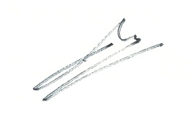
Alberto Behar

