considerations regarding an acoustic criterion for
wind turbine acceptability

William K.G. Palmer¹
¹ TRI-LEA-EM, 76 Sideroad 33-34 Saugeen, RR 5, Paisley, ON, N0G 2N0, trileaem@bmts.com

- Introduction
A common regulatory acceptance criterion for wind turbine installation in Canada is that sound pressure level does not exceed 40 dBA outside a home when the wind speed at 10 metres elevation does not exceed 4 metres per second. A clue to the ineffectiveness of this criterion can be seen from over 2700 complaints filed in Ontario with regulators by residents living in homes where acoustic conditions were predicted in approved models to comply with the current criterion. Residents noted the intrusiveness of an imposed sound higher in amplitude and different in quality than the pre-existing background. Residents reported disrupted sleep, and adverse health consequences. Fundamental premises of Environmental Protection Acts^{[1]} (EPA) are that emissions of a contaminant such as noise should not cause an adverse effect including loss of enjoyment of normal use of property, or annoyance that lead to human health impacts.

- Method
  - Listening to impacted individuals
The first step was to listen to the complaints. The author sat face-to-face with many individuals who told of adverse impacts since wind turbines were erected. Some had looked forward to the installation of wind turbines, and at first did not notice much impact. As time progressed, they noticed changes. Sleeping patterns were interrupted. They were often tired. Some members of their family were bothered by nausea, others by dizziness or vertigo. Those with pre-existing diabetes spoke of difficulty controlling blood sugar. They spoke of migraines and blood pressure changes. They recounted cognitive issues and feeling mentally fuzzy. While there were other issues and no universal problem, the individuals were sincere as they recounted how their lives had changed for the worse. They found that when they went away from the wind turbines, their condition improved, but on returning the adverse conditions resumed. While this paper does not pretend to give a medical diagnosis, or to identify a specific cause, the nature of the complaints were clues to search for changes in the environment that might explain what these people experienced.

  - Measuring background pre-turbine in service
Measurement of the background at homes distant from wind turbines, and before wind turbines were installed was conducted, in different seasons, and at different times of day. Often the rural environment background measurements challenged the 22 dBA noise floor of the Earthworks M30BX 9Hz to 30 kHz (± 1/-3 dB) microphone used or the 30 dBA noise floor of Level 2 sound level meters.
  - Monitoring outside homes post wind turbines
Measurements were conducted again at many of the same locations where pre-turbine monitoring had been conducted after wind turbines were erected and also both near to and distant from operating wind turbines, in a similar environment of weather, wind, and traffic.

  - Monitoring inside homes post turbine start-up
The reports of a number of individuals suggested that monitoring inside homes was also required. The narratives at first seemed to defy logic. Individuals described how:
- Because sleep was poor inside their homes, they tried sleeping in a tent outside, and found it was better.
- Some family members could not sleep in bedrooms and moved into basement rooms to try to get some rest.
- In a restless night, they might even try reversing their head to foot position in bed.

- Results
  - Conditions outside: changes post turbines
Without turbines, during spring and summer insects and birds often caused sound backgrounds of 35 dBA or more detectable as audible higher frequency peaks in a FFT analysis of sound samples. But, at night and particularly in the fall and winter without leaves on trees or insects, the background was very low, and the call of coyotes several km from the measurement site might be clearly detected. Some test sites would show traffic noise during times such as “shift change” at nearly plants, but those sounds were intermittent and ended before bedtime. Other monitoring was conducted at sites near streams or the shore of Lake Huron, where wave action was present. Inspection of recordings taken showed a randomness of the wave pattern and a smooth rise and fall of the sound different from sharp, regular pattern of rise and fall near the wind turbines. Pre-turbines the rural background measured at night was often 10 to 15 dBA below the 40 dBA current acceptability criterion, and random events without a particular pattern predominated. A bird might call, but birds would then be quiet, particularly after dusk. Post wind turbine start up, several differences were readily identifiable. At homes near the wind turbines, while the dBA readings post turbine start up might be within the 40 dBA limit, the flat weighted sound pressure levels often increased by 10 to 15 dB. The low frequency component of the sound shown by a FFT analysis was 15 to 20 dB higher at frequencies below 500 Hz. The soundscape, or acoustic environment, was significantly altered. In particular the cyclic broadband sound variation in sequence with the blade/tower interaction was readily identifiable. After wind turbines were in service there was no hearing of distant sounds such as coyotes, or farm livestock. The dBA numbers might not be much different. But the condition was very different.

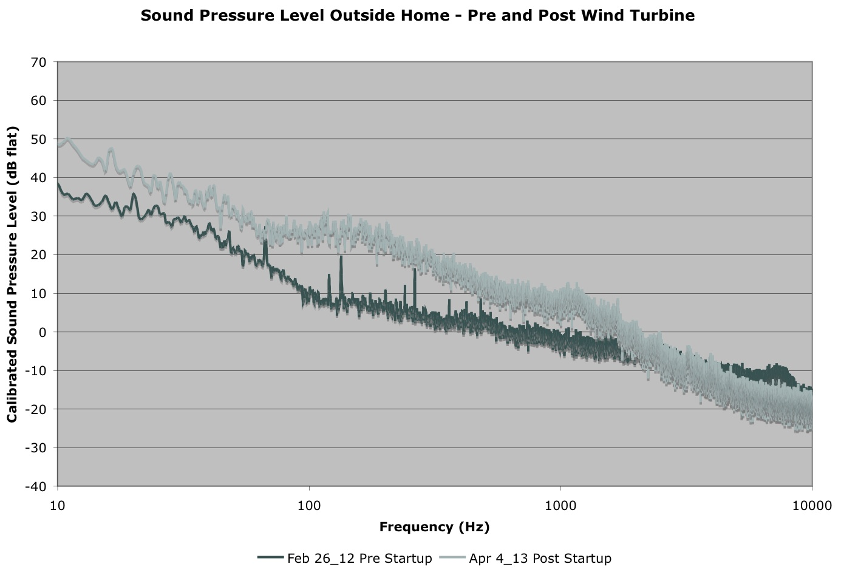
Figure 1: Level weighted sound pressure levels outside a home pre- and post-turbine startup (only one example of many)
  - Conditions inside homes differ from outside
The results of monitoring inside a typical Ontario farm with tall, square bedrooms, showed that the greatest sound pressure levels were in the corner of the room, and that the centre of the room had the lowest levels. Inside the home, the sound levels were greater at low frequencies, and more tonality was noted between about 10 Hz and 400 Hz than outdoors.

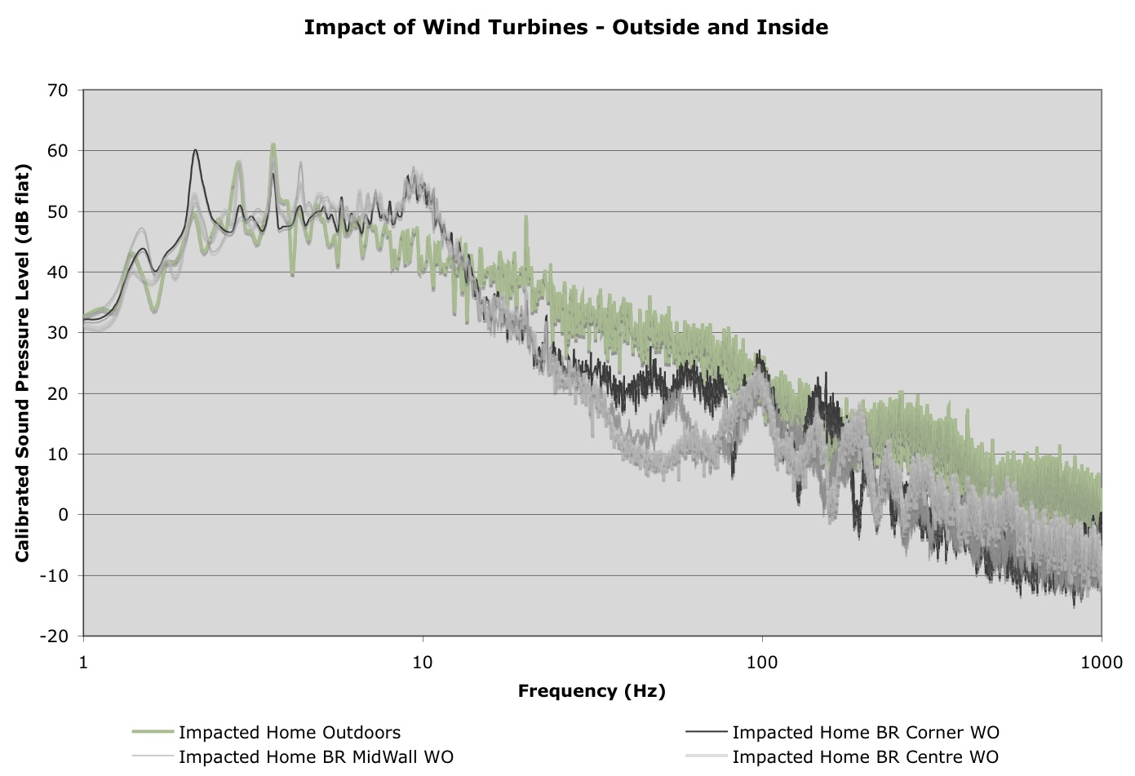
Figure 2: Level weighted sound pressure levels inside and outside home impacted by wind turbines (note cyclical blade pass tonality)
  - Acceptance criterion insensitive to change
The 40 dBA regulatory acceptance criterion is insensitive to the actual changes that take place, which increase the sound levels at frequencies below the values at which the dBA ratings are most sensitive. The acceptance criterion is insensitive to flag the change in the night time conditions, where the sound levels change by 10 to 15 dBA after wind turbines are erected – from perhaps 25 dBA to about 40 dBA. The acceptance criterion is unable to detect the changes inside homes, where sound levels actually can become higher inside than outdoors, and show more tonality. The acceptance criterion does not detect or act on the cyclical nature of the sound outside or inside impacted homes.
- Discussion
The subject of amplitude modulation of wind turbine noise emissions (otherwise described as a cyclical noise rising and falling in magnitude) has been a principal focus of wind turbine noise international conferences in Glasgow (2015) and Denver (2013). Monitoring of the sound inside homes displays a different character than outside, showing pulses with peak to trough amplitudes exceeding 5 dB at frequencies that are within the audible range. A simple example shows that dBA weighting does not adequately reflect perception and annoyance. White noise at 40dBA has a very different perception than pink noise at 40 dBA.

- Conclusion
The prevalence of complaints from residents impacted by wind turbines and the difference between pre- and post-wind turbine noise measurements and quality shows that the current regulatory acceptance criterion is ineffective at meeting the objectives of the EPA(s). Post-turbine changes should not cause annoyance that results in loss of enjoyment of normal use of property, or lead to adverse human health impacts. Changes in the intrusiveness of wind turbines compared to background are not sensed and are not being monitored. It has already been suggested that the cyclical nature of the sound from wind turbines is a contributing factor in complaints^{[2]}. Others have suggested that monitoring conditions inside homes should be considered^{[3]}. Revision of the regulatory acceptance criterion for wind turbines is called for to meet EPA objectives.

Acknowledgments
Many contributed to this work. Their assistance and inspiration is appreciated, but they are blameless for the presentation. The author acknowledges the patience of citizens living near wind turbines to permit acoustic monitoring outside and inside their homes. Early work by G.P. (Fritz) van den Berg alerted readers of annoyance from the sound of wind turbines. John E. Coulter raised concerns of cyclical noise as an annoyance factor before an Ontario Municipal Board Tribunal. Kerstin Persson Waye cemented the idea of cyclical noise annoyance. Comments of Brigitte Schulte-Fortkamp and Klaus Genuit guided understanding of soundscape and psychoacoustics. Discussions with Mathais Basner and Wolfgang Babisch aided in understanding the effect of noise on man.

References
[1] Environmental Protection Act, Ontario, R.S.O. 1990, c.E.19, 14
[2] J.E. Coulter. Testimony before Ontario Municipal Board 2007, PL060986.
[3] B. Howe, N. McCabe, I. Bonsma, Addressing low frequency sound and infrasound from wind turbines, JCAA (39) No.3 (2011)

