Noise Isolation Class (NIC) Testing of Modular Office Partitions
Andrew Williamson*
¹RWDI AIR Inc., 301-2250 Oak Bay Avenue, Victoria, BC, V8R 1G5

- Introduction
A trend in the design of new office spaces, and the renovation of existing office spaces, is the use of modular partitions that terminate at suspended acoustic tile (T-bar) ceilings. These partitions permit office spaces to be reconfigured in the future with less effort than would be required with conventional gypsum wall board (GWB) partitions. Modular partitions, however, present challenges in terms of providing adequate acoustical privacy as they must be sealed around their perimeter joints to avoid sound leakage and there is also potential for sound to travel over the partitions via the ceiling plenum. While the ceiling plenum transmission can be addressed by selecting ceiling tiles with an appropriate ceiling attenuation class, and/or by inserting barrier elements into the plenum space, providing effective seals at the perimeter joints can be more challenging. Furthermore, modular partitions that demise offices from corridors or open-plan work areas, also require effective seals around the perimeters (including bottoms) of doors. This paper presents 2 case-studies of Noise Isolation Class (NIC) tests which highlight the challenges involved in providing acoustical privacy when using modular partitions.

- NIC Test Methodology
For both NIC tests, a loudspeaker was used to broadcast pink noise in a corridor near the modular partitions. The loudspeaker was placed around the corner from the partition being tested, however, to avoid exposing the modular partition to the direct sound field. Spatially averaged, one-third octave band measurements were then conducted at various locations in the corridors and offices to determine the average noise levels in these spaces and the resulting NICs.

- Case Study 1 – Office Building
  - Purpose of Tests
Two NIC tests were conducted of a modular partition which was to form the corridor wall of a new private office. These tests were conducted on a partition which was mocked-up while construction was still in progress in order to verify that the NIC provided by the modular, corridor wall would be adequate. For the first test (Test 1), a sheet of GWB was placed against the door jamb and the resulting cavity formed between the sheet of GWB and the door was filled with insulation. Test 1 was conducted to determine the NIC provided by the modular partition while limiting the influence of noise transmission through the door. A primary goal of Test 1 was to evaluate the performance of the perimeter joint seals. For the second test (Test 2), the sheet of GWB and insulation were removed to determine the NIC that would actually be provided by the modular partition when the influence of sound transmission through the door was included.

  - Description of Test Partition and Installation
The modular partition consisted of an extruded aluminum frame equipped with double glazing consisting of 10 mm laminated glass separated by a 75 mm airspace from a layer of 5 mm laminated glass. The partition extended horizontally between two GWB walls and extended vertically from a carpeted floor to a GWB bulkhead in the suspended acoustical tile ceiling. This bulkhead extended vertically from the acoustical tile ceiling to the structural ceiling above in order to control noise transmission via the ceiling plenum. All four sides of the modular partition were sealed to the various surfaces using PVC gazetting, referred to as “zipper seals”. A photograph of a “zipper seal” is provided in Figure 1.

Figure 1: Photograph of PVC “Zipper” Seal

The top and bottom of the partition also included aluminum “runner tracks” which were directly fastened to the floor and ceiling surfaces. Both the office and corridor sides of the wall were equipped with the zipper seal (i.e., a pair of zipper seals along each side of the wall). The cavities formed between the two sets of seals were plugged along the sides with strips of 25-mm diameter closed cell foam and filled along the top and bottom with denim insulation. The corridor door was of solid wood core construction with both perimeter and bottom seals.

  - Results
The results were NIC 36 for Test 1 and NIC 27 for Test 2. The one-third octave band Noise Reductions (NR) obtained in the two tests are plotted in Figure 2.
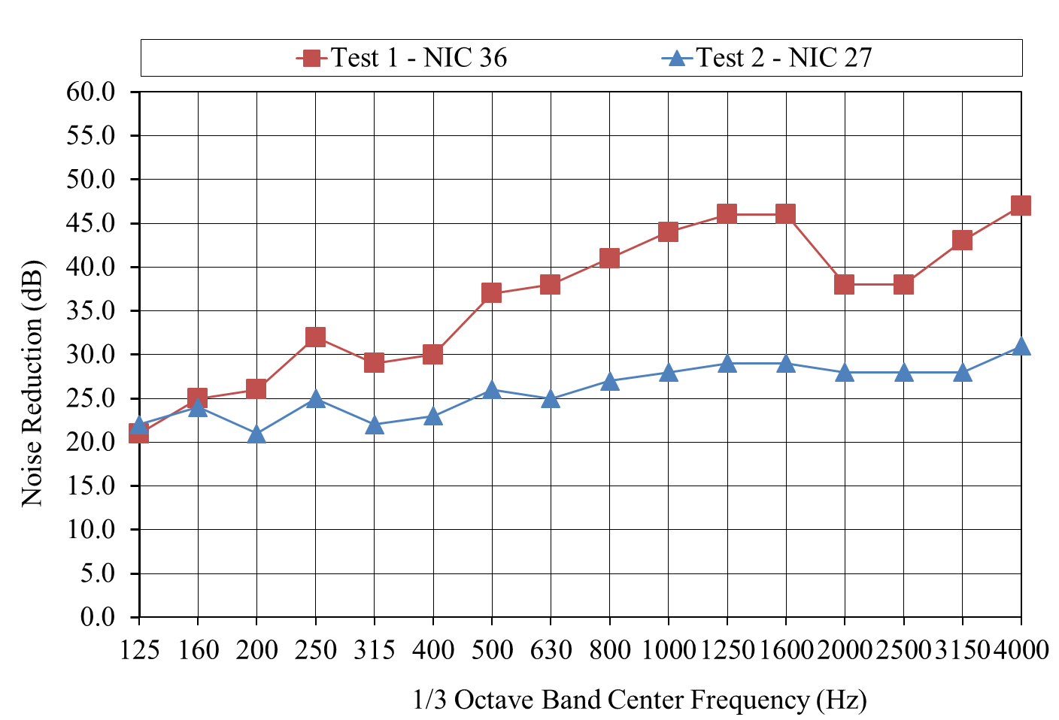
Figure 2: Results of Case Study 1 NIC Testing

From Figure 2 it can be seen that including noise transmission via the door (Test 2) reduced the NR by up to 17 dB. Without the GWB sheet in place, the door was the dominant noise transmission path. During Test 1, a “listening test” did not reveal the presence of any obvious sound leakage. Furthermore, the shape of the Test 1 NR curve does not indicate the presence of any significant leakage via the seals.

- Case Study 2 – College
  - Purpose of the Tests
A series of NIC tests were conducted on a modular partition that was used as the corridor wall of an examination writing room at a college. The tests were undertaken because the acoustical privacy provided by the modular partition was considered to be inadequate by the staff and students of the college. Various measures were employed to increase the NIC of that partition and NIC tests were performed after each of the following measure were implemented:

- Test 1: initial test, no noise control measures
- Test 2: upgraded from single to double-glazing and added mechanical door bottoms
- Test 3: added 25-mm diameter closed cell foam backer rod to one of the side seals

No data was collected from Test 2 because significant sound leakage was observed at the one of the partition’s side seals. The results were therefore not expected to show much improvement compared to those obtained in Test 1. The leakage was addressed prior to Test 3 through the addition of the backer rod.

  - Description of Test Partition and Installation
The modular partition initially consisted of an extruded aluminum frame with a single layer of 6 mm tempered glass. The installation conditions of the modular partition were identical to those of Case Study 1 including the presence of a GWB bulkhead above the acoustic tile ceiling. The PVC seals used along the top, bottom and sides of the modular partition were also similar to those used in Case Study 1 although it was unclear if the cavities formed between the seals on either side of the partition were void or filled. While the door was solid core wood, it was not initially fitted with a mechanical door bottom.

  - Results
The results were NIC 19 for Test 1 and NIC 31 for Test 2. The one-third octave band Noise Reductions (NR) obtained in the two tests are plotted in Figure 3.

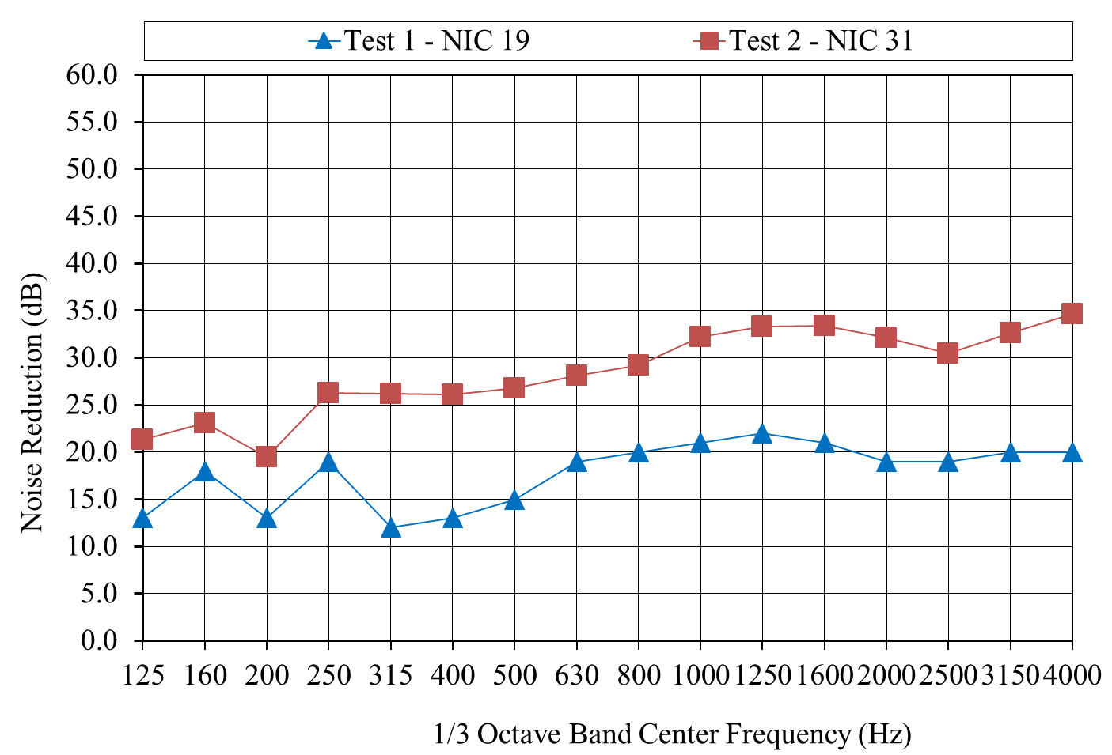
Figure 3: Results of Case Study 2 NIC Testing

Referring to Figure 3, it can be seen that upgrading the glass from single- to double-glazing, installing the mechanical door bottom and plugging the side seal with backer rod increased the one-third octave band NR by up to 14 dB. Despite the addition of the mechanical door bottom, however, noise transmission via the door was still the dominant noise transmission path.

- Conclusions
The results of the two case studies illustrate the limits of obtainable NICs when using modular partitions as corridor walls. However, these limits are closely related to the performance of the corridor wall door as is generally the case with more conventional GWB corridor walls. As such, when used as a corridor wall, modular partitions can provide similar acoustical performance to GWB walls (assuming the use of conventional doors rather than acoustical doors). However, when using modular partitions, special care must be taken to ensure that all potential sound transmission paths have been addressed. Of particular importance are controlling sound leakage via the perimeter seals and sound transmission over the partition through ceiling plenum. Furthermore, appropriately designed double glazing should be used when modular partitions include glazed sections.

* andrew.williamson@RWDI.com

