SLR Consulting – Noise and Vibration Environmental Specialists
Briony Croft ^{∗1} and Pascal Everton ^{†2}
¹SLR Consulting Canada Ltd, 200-1620 West 8th Avenue, Vancouver, BC, V6J 1V4.
²SLR Consulting Canada Ltd, 1185-10201 Southport Road SW, Calgary, AB, T2W 4X9.

Résumé
SLR est un bureau-conseil multidisciplinaire, fournissant des services environnementaux spécialistes à travers un réseau de bureaux aux États-Unis, Canada, Europe, Australie-Pacifique et en Afrique. Notre équipe mondiale en acoustique est le résultat de l’acquisition de deux entreprises, chacune avec plus de 35 ans d’histoire, l’ancien Heggies en Australie et HFP Acoustical Consulting en Amérique du Nord. Nous employons maintenant environ 90 conseillers spécialisés en acoustique à travers le monde. Une grande force de notre équipe est la capacité de tirer parti de notre expérience globale. Notre équipe d’acoustique Canadienne est au service des clients partout au Canada, aux États-Unis et à l’étranger.

Mots clefs : acoustique, bruit, vibration, environnementale, ferroviaire, transport, global, faune

Abstract
SLR is a multi-disciplinary consultancy providing specialist environmental services through a network of offices in the USA, Canada, Europe, Australia-Pacific, and Africa. Our global acoustic team came on board via the acquisition of two companies each with over 35 years of history, the former Heggies in Australia and HFP Acoustical Consulting in North America. Worldwide, we now employ around 90 specialist acoustic consultants. A great strength of our team is the ability to draw on our global experience. Our Canadian acoustics team services clients across Canada, the US and internationally.

Keywords: acoustics, noise, vibration, environmental, rail, transportation, global, wildlife

- Introduction to SLR
SLR Consulting (Canada) Ltd. is a multi-disciplinary consultancy providing worldwide environmental sciences, engineering expertise and high-value advisory services through a network of offices supporting approximately 1200 environmental professional staff globally. With 17 offices and more than 210 employees in Canada, SLR is recognized as a leader in the provision of Environmental Services.
SLR’s global acoustic team came on board predominantly through the acquisition of two companies each with over 35 years of history providing acoustic services, the former Heggies in Australia (acquired in 2010) and HFP Acoustical Consulting in North America (acquired in 2014). Worldwide, we now employ around 90 specialist acoustic consultants, with almost a third of these located across North America. Our Canadian locations offering acoustic services are Vancouver and Calgary, supported when needed by field staff from our distributed offices shown in Figure 1.
Our global experience gives us a unique perspective on environmental noise in British Columbia. This paper provides some examples of situations where we have been able to apply experience of best environmental noise practices elsewhere to BC, Canadian and North American projects.
* bcroft@slrconsulting.com
† peverton@slrconsulting.com

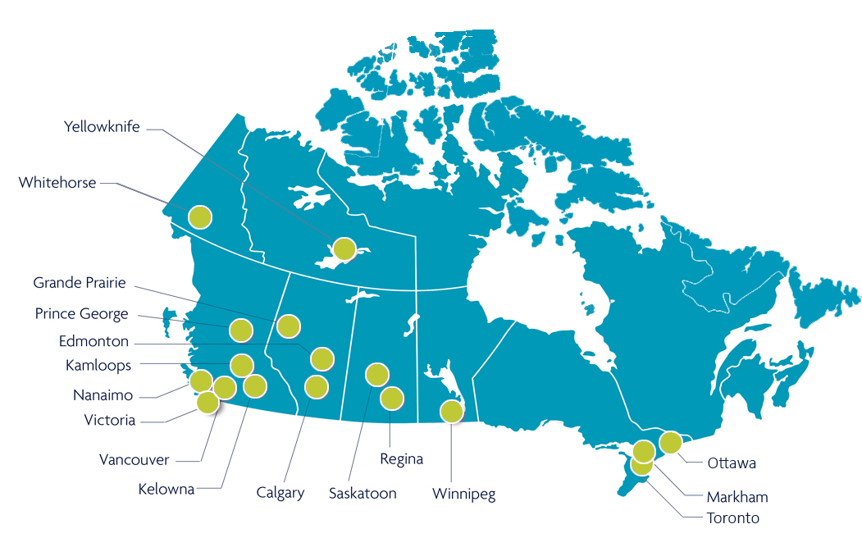
Figure 1: SLR’s Canadian Office Locations.

- Overview of Acoustics Services
Our team’s expertise can be employed in a variety of ways, from providing guidance on architectural acoustics to carrying out full environmental noise impact assessments for major industrial facilities and infrastructure projects. We offer advice on mitigating measures to balance potential environmental issues with the need for development. SLR also undertakes design and implementation of noise monitoring schemes to verify site compliance.
- Industrial facility assessments and noise control design
- Transportation noise and vibration assessments
- Architectural acoustical design
- PA speech intelligibility/audibility
- Underwater acoustics assessments
- Structural dynamics investigations and mitigation
- Mining / quarrying noise and blasting assessments
- Oil refinery and gas plant noise control
- Construction noise and vibration
- Wind farm noise assessments
- Environmental noise compliance surveys

- Selected Examples
  - Railway Noise and Vibration
In Canada, rail noise is federally regulated and noise complaints are adjudicated by the Canadian Transport Agency. Legislation requires freight companies to transport goods, and effectively means rail operators are not responsible for addressing any increases in noise and vibration arising from increases in rail traffic. For new projects, Environmental Impact Assessments during project planning stages are often the only point at which rail noise or vibration impacts are assessed.
Elsewhere in the world more stringent requirements for assessment and mitigation of noise from both rail freight and rail transit are common. These requirements have driven considerable research and development in Europe and elsewhere into best practices for rail noise and vibration control and railway noise policy. SLR’s Vancouver team has internationally recognized experience of current best practices in areas including:
- Rail grinding and roughness implications for noise
- Transit source noise and vibration control
- Curve squeal noise mitigation
- Rail dampers for in-car and guideway noise mitigation
- Mitigation for new developments near rail
- Noise from freight rail yards
- Freight locomotive noise

  - Noise Management Plans
Existing mines, ports and industrial sites in British Columbia sometimes find they are increasingly receiving noise complaints. In some cases, they may have expanded or made changes to their operations over time resulting in increased noise emissions. In other cases, new residential developments increase the population near the site. Or, sometimes neighbours’ expectations can change over time.
For many industries and jurisdictions there are no clearly defined noise limits. Local bylaws are often “nuisance” based and require a subjective interpretation of what noise is reasonable.
In this situation, SLR recommends development of a facility specific noise management plan. This plan can be developed in consultation with local government stakeholders and provincial regulators to define measurable noise goals, acceptable levels at different times of day, and procedures for ongoing monitoring. A noise management plan eliminates subjectivity, provides clearly defined responsibilities and sets a pathway to demonstrate best practices for balancing noise emissions with impacts to neighbours. Recent projects involving noise management plans include:
- Sand and gravel mine noise management plans
- Blast noise management plans
- Artic drilling noise management
- A coordinated plan to manage cumulative noise from multiple adjacent industrial facilities

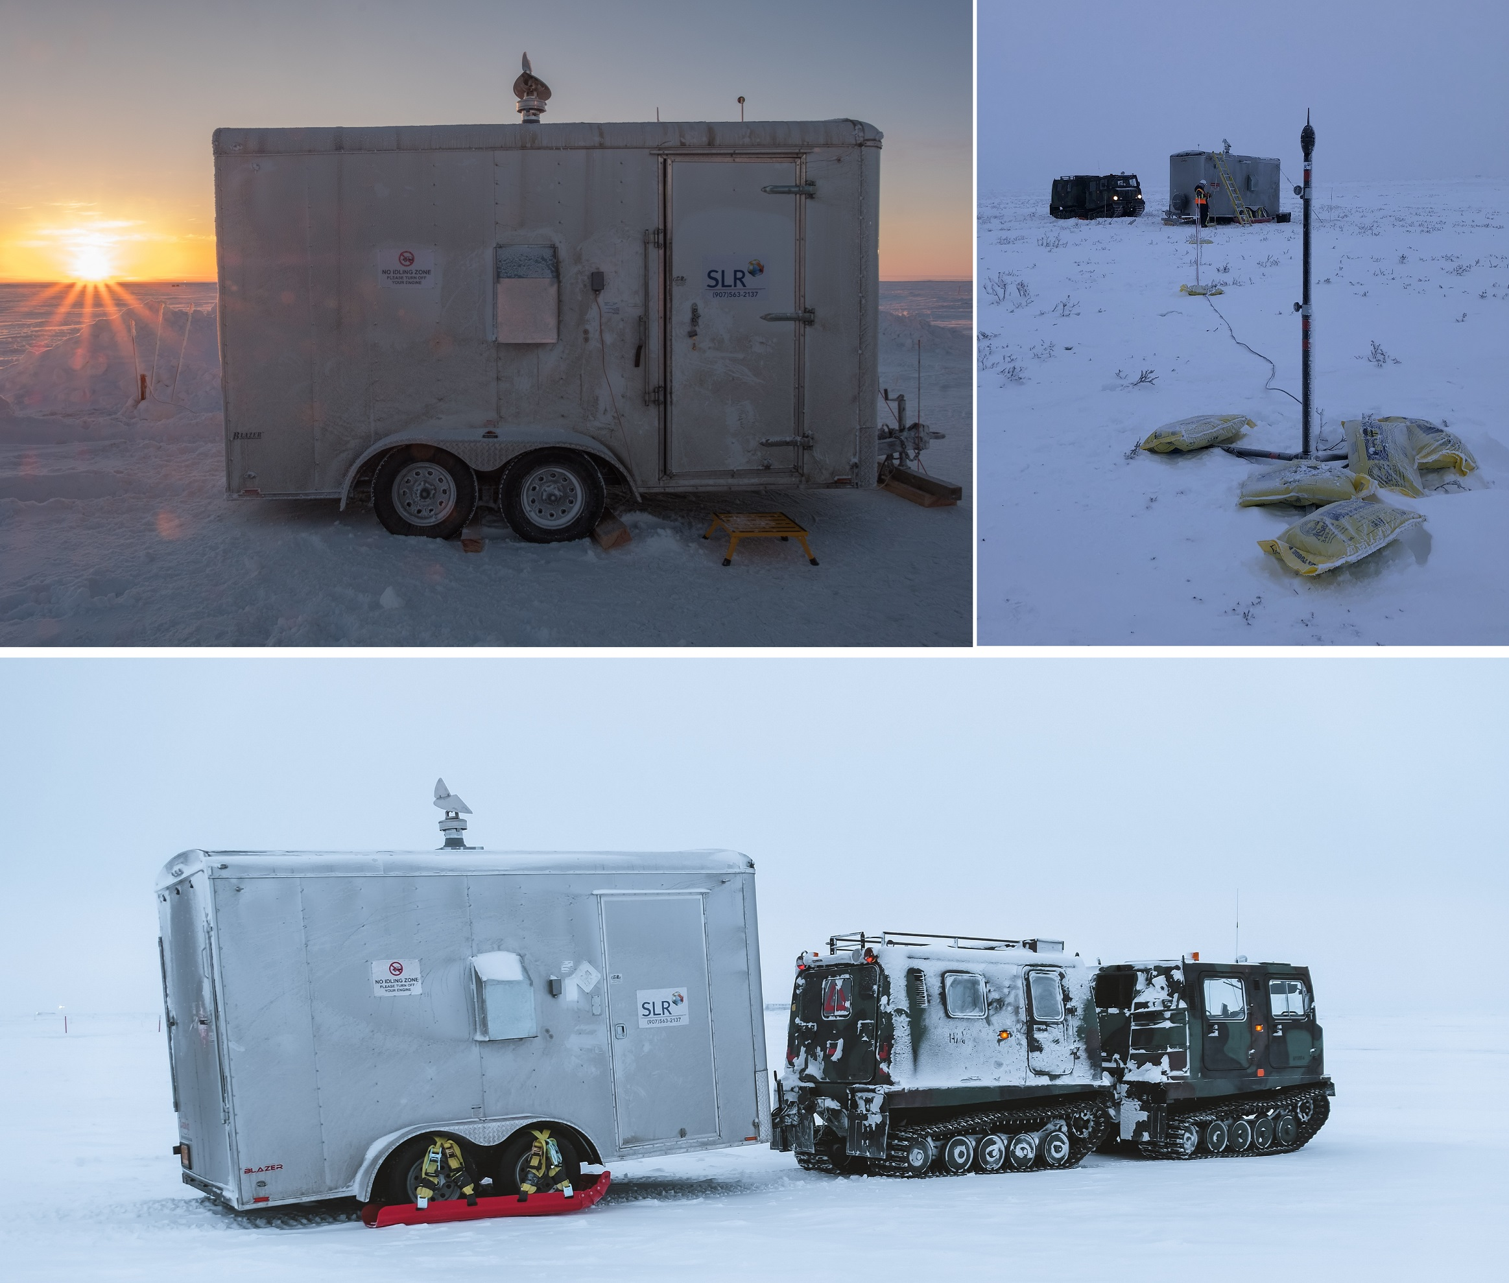
Figure 2: Arctic Noise Monitoring.

  - Noise and Wildlife (Land and Underwater)
The effect of noise from human activities on fauna is increasingly a subject of concern in the community when proposing developments such as new infrastructure, mines or industrial developments. This is particularly the case for projects along the BC coastline or in remote areas.
There are often no Canadian policies or accepted guidelines for noise levels or thresholds that may have an adverse effect on wildlife. The lack of policies is understandable when considering that responses to noise disturbance cannot be generalized across species.
In assessing noise impacts to wildlife, SLR combines acoustics and ecology expertise to determine appropriate precautionary parameters for each situation and to identify extents of habitat that may be affected. Assessments undertaken recently have included:
- Underwater overpressure and vibration due to blasting in and near fish-bearing inland water bodies
- Quarry noise impacts to birds
- Underwater noise impacts to marine mammals and fish
- Linear infrastructure construction noise and airblast impacts to bats and bumblebees

For More Information
https://slrconsulting.com/na/services

