**Acoustics Week in Canada 2017**

More than 185 people converged to learn, share and socialize at Acoustics Week in Canada 2017. The event was hosted October 11-13, 2017 at the Delta Hotel and Conference Centre in Guelph, Ontario.  The conference featured 3 keynote speakers, technical presentations and a large exhibition of acoustical products and services.

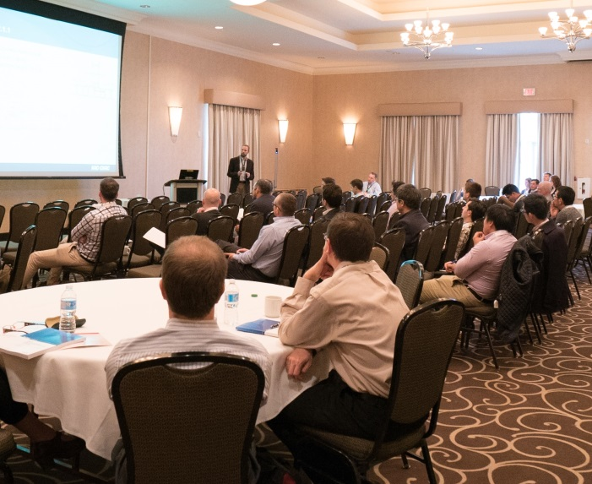The conference brought together thinkers and doers in Canadian Acoustics to discuss current developments in the field. Wednesday started with a keynote address by Elliot Berger titled Bang! Damage from Impulse Noise and the Effectiveness of Hearing Protection, which was followed by a day packed with technical presentations. The first feature of Thursday was John Bradley’s keynote titled A Rationale for a National Classroom Acoustics Standard. The technical presentations which followed also featured an extensive workshop on Tools and Guidelines for the Calculation of ASTC by Christoph Hoeller and Jeffrey Mahn of the National Research Council. The final morning of technical presentations was started with a keynote by Samir Ziada titled Flow-Excited Acoustic Resonances in Shallow Cavities. All in all, the papers and presentations illustrated the diverse subjects covered within the association. However no subject area was better represented than architectural acoustics, with one third of the papers in this subject area. The presentations sparked many discussions – during breaks, meals and social events.

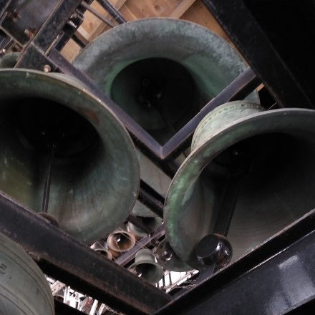

The social events began with a choice of two tours on Wednesday afternoon. The first was to the 36-bell carillon and historic pipe organ at St. George’s Church, which were both capably demonstrated by Gerald Manning. The second tour was to RWDI’s newly-constructed testing facilities, where some of cutting-edge science and testing were on display.

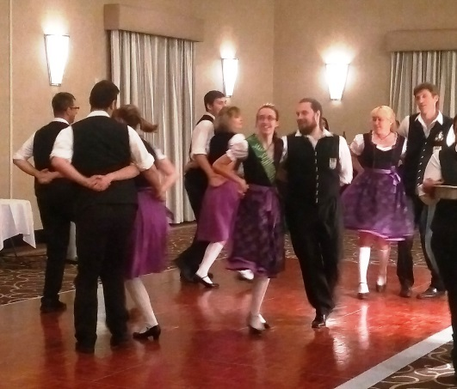

An Oktoberfest-themed reception followed the tours on Wednesday evening, in keeping with the Bavarian Oktoberfest festival running at the same time in nearby Kitchener-Waterloo. Characteristic foods like roulade, schnitzel, sauerkraut and pretzels were enjoyed with local craft beers. Traditional German music and a performance by a dance troupe from the Schwaben Club rounded out the Bavarian theme.

Products and services relevant to the field of acoustics were showcased in a well-attended exhibition which began on Wednesday evening and continued during the breaks and lunch on Thursday. There was a large assortment of things to see, try and discuss. Many people took the opportunity to make or renew connections with the 30+ exhibitors who were present.

The distinctive atrium of the University of Guelph’s Summerlee Science Complex was the site of our banquet and annual awards ceremony. Details of the awards are reported elsewhere in the journal. The evening concluded with a diverse musical concert by the Artelli String Ensemble, made up of Guelph Symphony Orchestra members.

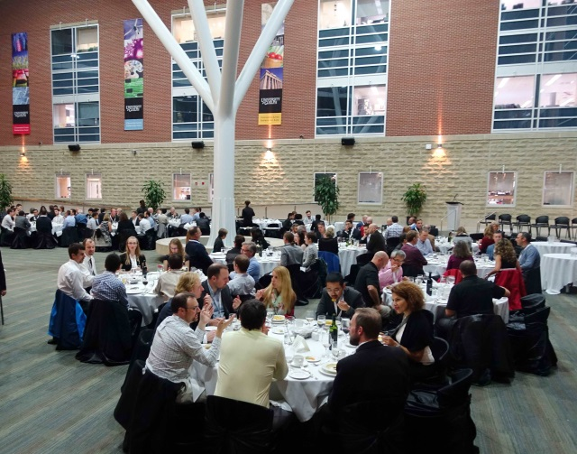 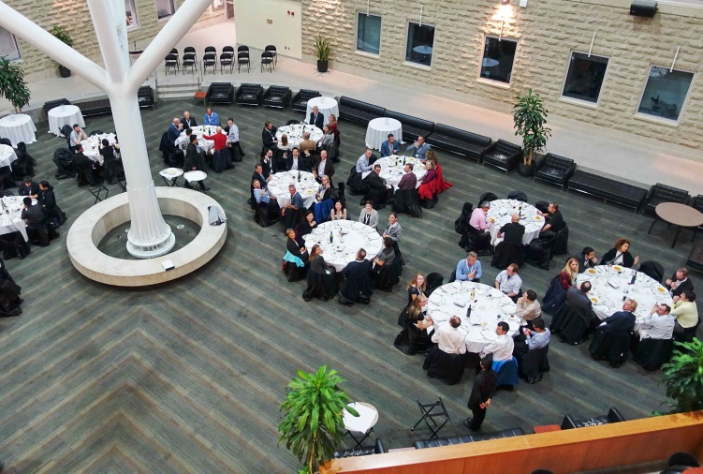

The successes of this conference are due to the efforts of many people. Thank you to all who attended and shared of their knowledge and experience. Special thanks to the generous sponsors who made it possible to add special features, enhance the meals for your enjoyment. And finally, to my fellow organizers: Christian Giguere, Kyle Hellewell, Dalila Giusti and Bernard Feder – we owe many thanks for the successful execution of this conference. Thank You! It has been my pleasure to serve you as conference chair.

Peter VanDelden